Assignment No. 06

Roll No. SC55 - Shreyas Chavhan

===================================================

# Implement Employee Database, Bio-data

## Problem Statement -

Create employee bio-data using following classes

i) Personal record

ii)) Professional record

iii) Academic record

Assume appropriate data members and member functions to accept required data & print bio-data.

Create bio-data using multiple inheritance using C++.

## Theory -

In C++, it is possible to inherit attributes and methods from one class to another. We group the "inheritance concept" into two categories:

* derived class (child) - the class that inherits from another class
* base class (parent) - the class being inherited from

To inherit from a class, use the : symbol.

In the example below, the Car class (child) inherits the attributes and methods from the Vehicle class (parent):

### Example

// Base class

class Vehicle {

public:

string brand = "Ford";

void honk() {

cout << "Tuut, tuut! \n" ;

}

};

// Derived class

class Car: public Vehicle {

public:

string model = "Mustang";

};

int main() {

Car myCar;

myCar.honk();

cout << myCar.brand + " " + myCar.model;

return 0;

}

## Code -

|  |
| --- |
| /*******************************************************************************  Create employee bio-data using following classes  i) Personal record  ii))Professional record  iii) Academic record  Assume appropriate data members and member function to accept required data & print bio-data.  Create bio-data using multiple inheritance using C++.  ********************************************************************************/  #include <iostream>  using namespace std;  class personal  {  protected:  char name[50];  char address[50];  char birthdate[50];  char gender;  public:  void get_personal();  };  class professional  {  protected:  int noofyearsexp;  char orgname[50];  char projname[50];  char projdetails[50];  public:  void get_professional();  };  class academic  {  protected:  int year;  int marks;  int percentage;  char Class[50];  public:  void get_academic();  };  class biodata : public personal, public academic, public professional  {  public:  void display();  };  void personal::get_personal()  {  cout << "Enter name::";  cin >> name;  cout << "Enter Address::";  cin >> address;  cout << "Enter Birthdate(dd/mm/yyyy)::";  cin >> birthdate;  cout << "Enter gender(M/F)::";  cin >> gender;  }  void professional::get_professional()  {  cout << "Enter number of years of exp::";  cin >> noofyearsexp;  cout << "Enter organization name::";  cin >> orgname;  cout << "Enter project name::";  cin >> projname;  cout << "Enter project Details::";  cin >> projdetails;  }  void academic::get_academic()  {  cout << "Enter academic year::";  cin >> year;  cout << "Enter total marks::";  cin >> marks;  cout << "Enter percentage::";  cin >> percentage;  cout << "Enter class::";  cin >> Class;  }  void biodata::display()  {  cout << "---------------------Employee Biodata--------------" << endl;  cout << "-----------------------------------------------------" << endl;  cout << "____________________Personal Details__________________________" << endl;  cout << "Name::" << name << endl;  cout << "address::" << address << endl;  cout << "birthdate::" << birthdate << endl;  cout << "Gender::" << gender << endl;  cout << "--------------------------------------------------" << endl;  cout << "________________Academic Details________________________" << endl;  cout << "Academic Year "  << "marks "  << "percentage "  << "class " << endl;  cout << year << "\t\t0" << marks << "\t" << percentage << "\t" << Class << endl;  cout << "-------------------------------------------------------" << endl;  cout << "_______________Professional Details____________________" << endl;  cout << "\nOrganization Name::" << orgname;  cout << "\nYears of Experince::" << noofyearsexp;  cout << "\nProject Done::" << projname;  cout << "\nProject Details::" << projdetails;  }  int main()  {  biodata b;  b.get_personal();  b.get_academic();  b.get_professional();  b.display();  } |

Roll No. SC55 - Shreyas Chavhan

===================================================

## Output -

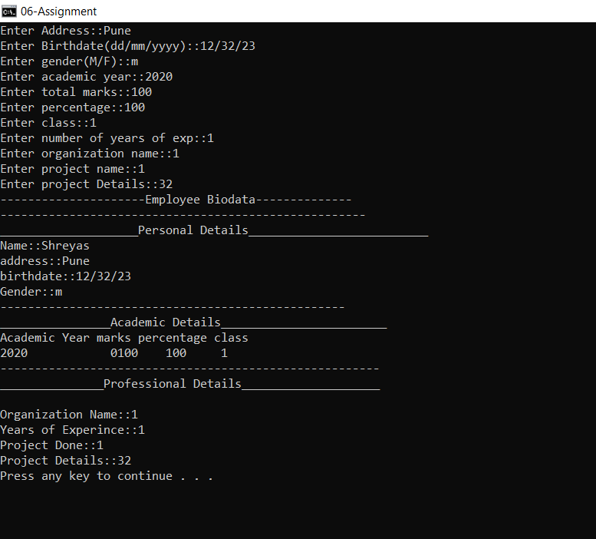

===================================================

Roll No. SC55 - Shreyas Chavhan